The Eatwell Guide food list

Food group | Examples of food included in this group
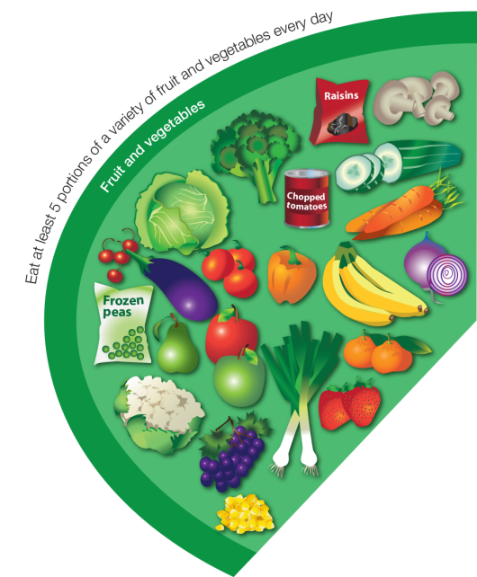  Fruit and vegetables | Apple, baked beans, banana, broccoli, cabbage, carrots, cauliflower, cucumber, fruit juice, fruit smoothie, grapes, kiwi, lettuce, melon, mushrooms, oranges, onions, pears, peas, peppers, pineapple, plums, raisins, strawberries, sweetcorn and tomatoes.  Fresh, frozen, dried, canned and juiced all count.
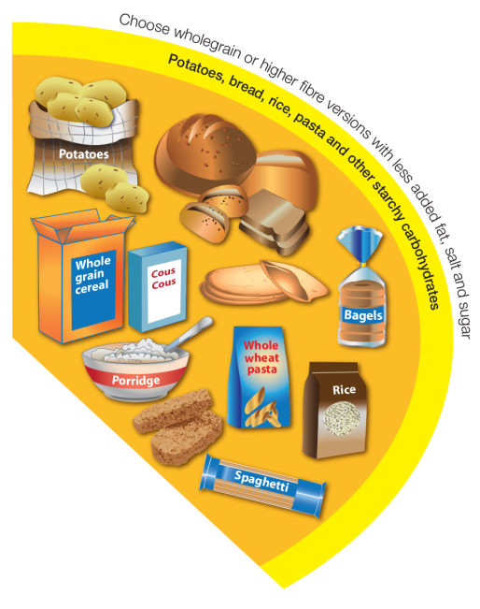  Potatoes, bread, rice, pasta and other starchy carbohydrates | Bread: soda bread, rye bread, pitta, flour tortilla, baguettes, chapatti and bagels.  Rice, potatoes, breakfast cereal, oats, pasta, noodles, maize, cornmeal, couscous, bulgur, polenta, millet, spelt, wheat, pearl barley, yams and plantains.
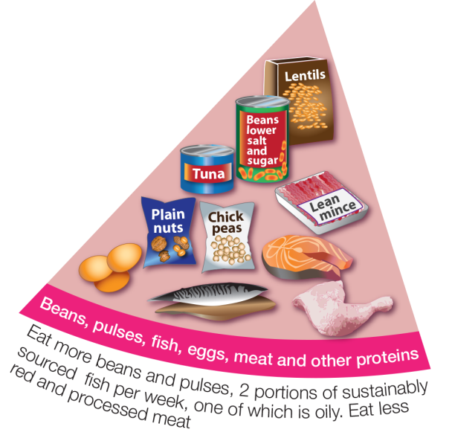  Beans, pulses, fish, eggs, meat and other proteins | Meat, poultry and game including: lamb, beef, pork, chicken, bacon, sausages and burgers.  White fish (fresh, frozen or canned) including: haddock, plaice, pollock, coley, cod and tuna.  Oily fish (fresh, frozen or canned) including: salmon, herring, pilchards, sardines, sprats, trout and mackerel.  Shellfish: including, prawns, mussels, crab, squid and oysters.  Nuts, eggs, beans and other pulses including: lentils, chickpeas, baked beans, kidney beans and butter beans.  Vegetarian meat alternatives e.g. tofu, tempeh and mycoprotein.
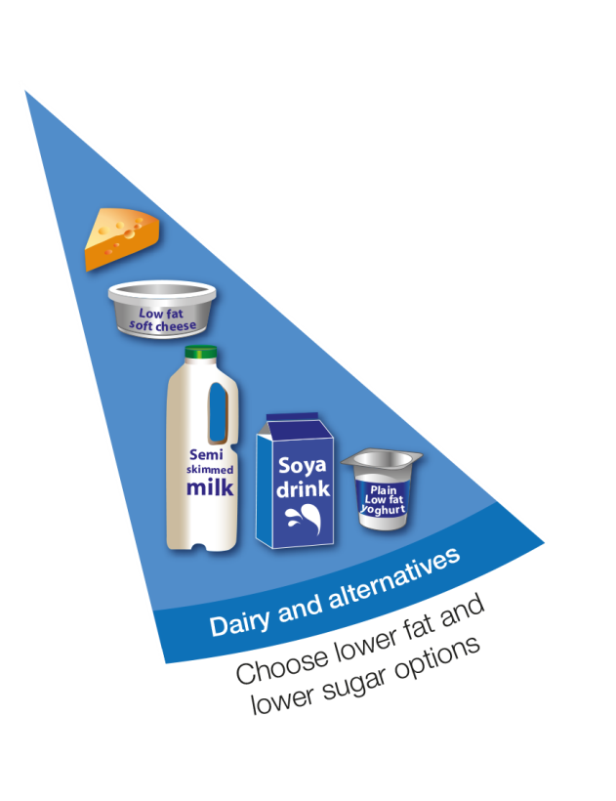  Dairy and alternatives | Milk, cheese, yogurt, fromage frais, quark, cream cheese.  This includes non-diary alternatives to these foods such as soya drinks.
  Oils and spreads | Vegetable oil, rapeseed oil, olive oil and sunflower oil.  Soft spreads made from these unsaturated oils.

